**How to backup and Restore onedev.io server**

1. Copy the entire folder and files form installation director which is in my example

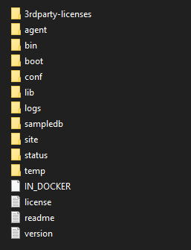

1. Path?
2. To save Docker image and load to different serve: pit fall Make sure u have the same docker image to restore your onedev data.
   * If you’re using Linux ssh into the server where Docker is running
   * first check the docker image is running using this command $docker images
   * Run the following command to save the docker image into your home dir.
   * $ docker save -o /home/sultan/1devserve.tar 1dev/serve:latest-data-1
   * Here in the right side I have used the image name with tag.
   * Link <https://docs.docker.com/engine/reference/commandline/save/>
   * To load your docker image to use the command
   * Go to the directory where you saved image and run this.
   * $ docker load –i 1devserve.tar 1dev
   * You can also use ssh to copy this image and send to another server
   * $ rsync -avc carnaticcorner.tar [myself@192.168.1.20:/home/sultan](mailto:myself@192.168.1.20:/home/sultan)
   * Once you load your image
3. Go to the onedev installation directory where you copied file and folders in the above line of this document
   * Open terminal run this command
   * docker run -it --rm -v /var/run/docker.sock:/var/run/docker.sock -v $(pwd)/Onedev/VenkatachalaOnedev/1dev/_data:/opt/onedev -p 6610:6610 -p 6611:6611 10ce6bd6191d
   * Once the server gets ready you can browse <http://localhost:6610/>